About the Customer

Bro4u Online Services Pvt LTD is an online marketplace that connects users with a variety of local services, including mobile car washes, laundry, plumbing, and electrical work. The platform offers a convenient way to book services directly or via WhatsApp. By taking a commission from each booking, Bro4u Online Services Pvt LTD ensures a curated selection of top-rated vendors while continuously enhancing its offerings for a seamless user experience.

Scope of Work
The migration from Amazon Web Services (AWS) to Google Cloud Platform (GCP) will follow a well-defined process to ensure a smooth transition. The Assessment phase is for understanding the current AWS environment and planning the migration. This involves cataloging resources and evaluating their alignment with GCP services.
- Catalog resources: List all current AWS assets.
- Evaluate alignment: Map AWS resources to GCP services.
- Develop migration plan: Detail strategy, timelines, and resources.
In the Data Migration phase, we will transfer data and applications to GCP. Key activities include using GCP Data Transfer services and the Database Migration Service.
- Use Data Transfer services: Move data efficiently with minimal downtime.
- Employ Database Migration Service: Ensure data integrity.
- Migrate virtual machines: Use Migrate for Compute Engine and replicate AWS network setup.
During the Testing and Cutover phase, we will test the systems in GCP to ensure proper functionality. This includes validating performance, data consistency, and network configurations.
- Test performance: Ensure applications work well in GCP.
- Verify data consistency: Check data integrity.
- Confirm network setup: Ensure Cloud DNS, Load Balancers, and Cloud CDN are configured correctly.
The migration will involve detailed planning, phased execution, and thorough testing to ensure a smooth transition to Google Cloud. Post-migration support will include GCP training, comprehensive documentation, and ongoing monitoring to address any issues that arise. The goal is to achieve a seamless transition with optimized performance and cost efficiency. This approach ensures that both the application and database are effectively transferred and maintained.
- Conduct testing to ensure functionality and performance.
- Provide training and documentation for GCP.
- Implement monitoring with Google Cloud Monitoring, logging with Google Cloud Logging, and establishing security practices using Google IAM and Security Command Center.
Architecture Diagram
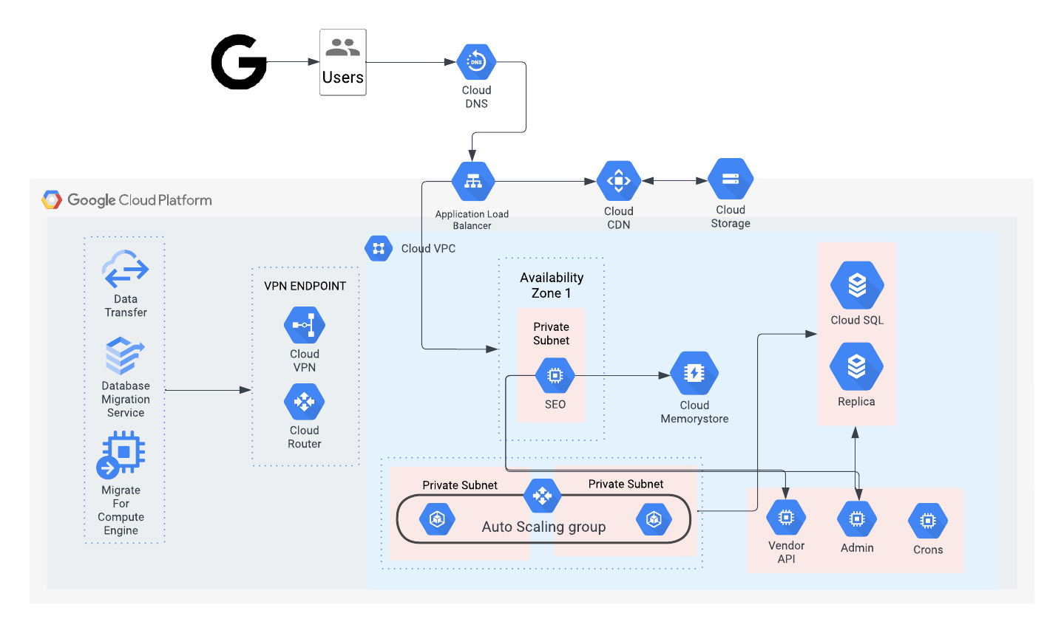
Architecture Description
- Cloud DNS: Directs internet traffic to the correct GCP resources.
- Application Load Balancer: Distributes traffic across multiple instances of an application.
- Cloud CDN: Delivers content quickly to users around the world.
- Cloud Storage: Stores data securely and efficiently.
- Data Transfer: Handles the movement of data from AWS to GCP.
- Database Migration Service: Migrates databases from AWS to GCP.
- Migrate for Compute Engine: Assists in migrating virtual machines from AWS to GCP.
- Cloud VPN: Creates secure connections between GCP and on-premises networks.
- Cloud Router: Manages network traffic within GCP.
- Cloud VPC: Provides a private network for your resources.
- Availability Zone: A geographical location with multiple data centers.
- Private Subnet: A network within a VPC that is not accessible from the public internet.
- Autoscaling Group: Automatically adjusts the number of instances based on demand.
- Cloud Memorystore: A managed Redis service.
- Cloud SQL: A fully managed relational database service.
- SQL Replica: A copy of a Cloud SQL instance for disaster recovery.
- Vendor API (Compute): Allows interaction with GCP compute resources through APIs.
- Crons (Compute): Schedules tasks to run at specific times.
- Admin (Compute): Manages compute resources within GCP.

Workflow:
- Assessment: Analyze existing AWS infrastructure to determine the best migration strategy.
- Data Migration: Move data from AWS to GCP using Data Transfer and Database Migration Service.
- Infrastructure Setup: Create VPCs, subnets, and other network components in GCP.
- Application Migration: Migrate applications to GCP using Migrate for Compute Engine or other tools.
- Configuration: Configure load balancers, DNS, and other components.
- Testing: Thoroughly test applications and infrastructure in GCP.
- Cutover: Switch traffic from AWS to GCP.

Google Pricing Link
https://cloudpricingcalculator.appspot.com/#!?id=63e9813f-997b-46d6-a7a3-ff2728dd3b77#resultBlock
Timeline
20 Days

Resource Matrix

S.No | Name | Total Man Days
1 | Sr.Cloud Engineer | 10
2 | Sr.DevOps Engineer | 10
3 | Project Manager | 2

